- Copyright for test papers and marking guides remains with West Australian Test Papers.
- The papers may only be reproduced within the purchasing school according to the advertised conditions of sale.
- Test papers must be withdrawn after use and stored securely in the school until December 3rd.

Insert School Logo
PHYSICS

UNITS 1 & 2

2021

Name: _______________________________________________________

Teacher: ___________________________________________________

TIME ALLOWED FOR THIS PAPER

Reading time before commencing work: Ten minutes
Working time for the paper: Three hours

MATERIALS REQUIRED/RECOMMENDED FOR THIS PAPER

To be provided by the supervisor:
- This Question/Answer Booklet; Formula and Constants sheet

To be provided by the candidate:
- Standard items: pens, pencils, eraser or correction fluid, ruler, highlighter.

- Special items: Calculators satisfying the conditions set by the SCSA for this subject.

IMPORTANT NOTE TO CANDIDATES
No other items may be taken into the examination room. It is your responsibility to ensure that you do not have any unauthorised notes or other items of a non-personal nature in the examination room. If you have any unauthorised material with you, hand it to the supervisor before reading any further.

Structure of this paper

Section | Number of questions available | Number of questions to be answered | Suggested working time  (minutes) | Marks available | Percentage of exam
Section One:  Short answer | 13 | 13 | 50 | 55 | 30
Section Two:  Extended answer | 6 | 6 | 90 | 86 | 50
Section Three:  Comprehension  and data analysis | 2 | 2 | 40 | 35 | 20
 |  |  | Total | 176 | 100

Instructions to candidates

- The rules for the conduct of Western Australian external examinations are detailed in the Year 11 Information Handbook 2021. Sitting this examination implies that you agree to abide by these rules.

- Write your answers in this Question/Answer Booklet.

- When calculating numerical answers, show your working or reasoning clearly. Give final answers to three significant figures and include appropriate units where applicable.

When estimating numerical answers, show your working or reasoning clearly. Give final answers to a maximum of two significant figures and include appropriate units where applicable.

- You must be careful to confine your responses to the specific questions asked and follow any instructions that are specific to a particular question.

- Spare pages are included at the end of this booklet. They can be used for planning your responses and/or as additional space if required to continue an answer.
  - Planning: If you use the spare pages for planning, indicate this clearly.
  - Continuing an answer: If you need to use the space to continue an answer, indicate in the original answer space where the answer is continued, i.e. give the page number. Refer to the question(s) where you are continuing your work.

Section One: Short response 30% (55 Marks)

This section has thirteen (13) questions. Answer all questions. Write your answers in the space
provided. Suggested working time for this section is 50 minutes.

- (4 marks)
Justify whether the following statement is true or false: At the same temperature, atoms of helium move faster, on average, than atoms of xenon.

- (4 marks)
Explain the differences in penetration power between alpha, beta and gamma radiation.

- (4 marks)
A standard AA battery supplies a 1.20 V potential and sustains a 200 mA current. The battery lasts for 15.0 hours under these conditions before running out of energy. Calculate the electrical energy supplied by the battery.

Energy: ___________________ J

- (5 marks)
Ms Collins is doing a food shop at Coles. Seeing an item on her list, she pushes her 12.5 kg trolley from rest up to 1.70 m s⁻¹.

- Calculate the work done by Ms Collins on the trolley. (2 marks)

Energy: ___________________ J

- The trolley was moved 3.20 m during the acceleration. Calculate the average power at which Ms Collins transferred energy to the trolley. If you could not obtain an answer to part (a), use 18.5 J. (3 marks)

Power: ___________________ W

- (4 marks)
The threshold of pain for human hearing occurs when sound is at an intensity of 10.0 W m⁻². A jet engine produces a sound intensity of 562 W m⁻² at a distance of 2.00 m from the engine.

- Describe how sound intensity varies with distance from the source. (1 mark)

- Calculate how far from a jet engine the intensity of its sound will drop below the threshold of pain. (3 marks)

Distance: ___________________ m

- (4 marks)
Describe the difference between a longitudinal wave and a transverse wave. Provide an example of each type of wave to support your answer.

- (4 marks)
Calculate the net force acting on the plane shown in the free body diagram below. Treat up the page as the north direction.
Thrust
3000 N
Drag
2400 N
Cross wind
800 N

Net Force: ___________________ N

Direction: ______________________

- (4 marks)
Compare the purpose and function of a circuit breaker and an RCD.

- (4 marks)
Devices for charging mobile phones and laptops reduce the 240 V mains to something lower that the sensitive electronics can handle. A 19.0 V charger delivers 2.85 kJ to a laptop. Calculate the number of electrons delivered to the laptop via the charger.

Number: ___________________

- (4 marks)
A closed pipe is 1.35 m long and 15.0 cm in diameter.

- Calculate the wavelength of the fundamental wave that would resonate in the pipe.
(2 marks)

Wavelength: ___________________ m

- Calculate the length of an open pipe that could produce the same fundamental frequency as the closed pipe as in part (a). (2 marks)

Length: ___________________ m

- (3 marks)
A car radiator is designed with features that make it more effective in its role to cool the engine components of a car. For each feature below, describe how the feature improves the effectiveness of the radiator.

- Painted black

- Wavy/Rippled surface

- The radiator fluid has a high specific heat capacity

- (5 marks)
Electric ovens require a large current to deliver the power needed for the heating element. For the electrical supply to the oven, state if it would be better to use a short or long wire and state if it would be better to use a thin or thick wire. Justify your choices.

- (6 marks)
A soft drink company monitors the volume of soft drink added to cans by using a radioisotope. Radiation is directed through the can, near the top. A detector on the other side of the can monitors for radioactivity. When the detector picks up a significant drop in radioactivity as a can passes by, this is an indication the soft drink can was full.

- State which type of radiation would be suited to this application. Justify your choice.
(3 marks)

- For this application, state whether it would be better to have a radioisotope with a half life of 2 weeks or 2 years. Justify your choice. (3 marks)

End of Section 1
Section Two: Problem-solving 50% (86 Marks)

This section has six (6) questions. You must answer all questions. Write your answers in the
space provided. Suggested working time for this section is 90 minutes.

- (14 marks)
Thermodynamic properties of three alcohols are listed in the table below. You have a 100 g sample of each alcohol but are concerned the labels have been mixed up. You have access to a low temperature freezer that can be set between -150 ⁰C and -20 ⁰C, a calorimeter that can measure the amount of heat applied to a sample, and thermometers.

Alcohol | Liquid Specific Heat Capacity  (J kg⁻¹ K⁻¹) | Melting point  (⁰C)
1-propanol | 2400 | -126
2-propanol | 2570 | -90
1-butanol | 2400 | -90

- Describe a method to identify the 1-propanol sample from the other alcohols based on their thermodynamic properties. (2 marks)

- Describe a method to identify the 2-propanol from the other alcohols based on their thermodynamic properties. In your description, include the useful states of matter, measurements and/or calculations performed. (4 marks)

- The sample of 1-propanol at -45.0 ⁰C is added to the 2-propanol sample at 10.0 ⁰C. Calculate the final temperature of the mixture. (4 marks)

Temperature: ___________________ ºC

- Calculate the mass of water at 20.0 ⁰C required to raise the temperature of the 100 g sample of 1-butanol from -50.0 ⁰C to -15.0 ⁰C. (4 marks)

Mass: ___________________ kg

- (13 marks)
The triple-alpha process is a set of nuclear reactions that occur in the cores of stars in which three alpha particles are transformed into carbon. The first reaction is the fusion of two alpha particles to form Be-8. This reaction requires an input of 0.0918 MeV, taken from the star’s core. A third alpha particle fuses with Be-8 to form C-12. This second reaction releases 7.37 MeV.
- State the composition of an alpha particle. (1 mark)

- Write the first reaction of the triple-alpha process. (2 marks)

- Calculate the mass, in kilograms, gained by the fusion of the first two alpha particles.
(3 marks)

Mass: ___________________ kg

- Write the second reaction of the triple-alpha process. (2 marks)

- Calculate the net energy released by a completed triple-alpha process. (2 marks)

Energy: ___________________ MeV

- By successive fusion of additional alpha particles with the nucleus formed from the triple-alpha process, it is possible for stars to create heavier elements, like oxygen and neon. However, successive fusion of additional alpha particles alone will not create fluorine or sodium. Explain why. (3 marks)

- (13 Marks)
Consider the two circuits below, which have identical power sources and globes. Circuit A has three globes connected in series while circuit B has three globes connected in parallel.

$$V_{T}$$
$$V_{T}$$

Circuit B
Circuit A

- Which type of circuit, series or parallel, is better suited for lighting multiple rooms in a house? Justify your choice.
(2 marks)

- Redraw circuit A below with an ammeter and voltmeter included. The ammeter and voltmeter need to allow for the measurement of the current and voltage of a single globe.
(2 marks)

- Determine the equivalent resistance of the circuit in terms of the resistance of a single globe, R. Show clear working.

    - For Circuit A (2 marks)

    - For Circuit B (2 marks)

- By determining an expression for the power dissipated by a globe from each circuit in terms of the resistance of a single globe (R) and the voltage of the emf source (V_{T}), determine which circuit will produce a brighter light for a single globe. You can assume the light bulbs are of the same resistance and are Ohmic. (5 marks)

Circuit: ___________________

- (16 marks)
The reconstruction of a traffic accident based on the testimonies of eyewitnesses and evidence found on the road is shown below in three stages; before the collision, at the moment of impact, and after the collision. The skid marks seen in the diagrams reveal the distance over which Car 1 was braking hard. Car 1 has a maximum braking force of 16800 N. You may assume that Car 1 only ever applied the full force of its brakes.

Car 1
Car 2
Before collision
$$m=1200 kg v=75 km h^{-1}$$
$$m=950 kg v=0 km h^{-1}$$

13.0 m
Car 1
Car 2
Moment of impact

13.0 m
1.50 m
5.00 m

Car 1
Car 2
After collision

- Explain whether a car crash is an example of an elastic or inelastic collision. (3 marks)

- Show that the velocity at which Car 1 collided with Car 2 is approximately 8 m s⁻¹. (4 marks)

- Calculate the velocity of Car 1 just after the moment of impact. (2 marks)

Velocity: ___________________ m s⁻¹

Question 17 continued

- Hence, calculate the velocity of Car 2 just after the moment of impact. If you could not determine an answer to part (c) you may use 6.50 m s⁻¹. (3 marks)

Velocity: ___________________ m s⁻¹

- Explain how a car’s crumple zone would have reduced the chance that the driver of Car 1 was significantly injured. (4 marks)

- (17 marks)
The graph below shows the average binding energy per nucleon as a function of mass number. Some isotopes have been identified on the graph.
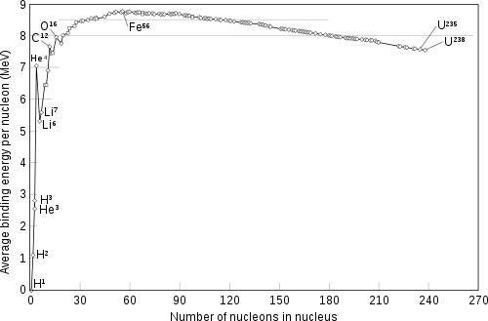
- Define the term ‘binding energy’ in the context of nuclear physics. (2 marks)

- With reference to the graph, explain which isotope is the most stable. (3 marks)

Question 18 continued

- Using the graph, calculate the mass defect (in atomic mass units) for the formation of O-16 from its constituent nucleons. (3 marks)

Mass: ___________________ u

- For light elements, the graph shows a pattern that the higher the mass number of an isotope of an element, the higher the average binding energy per nucleon (e.g.: ⁴H>³H>²H>¹H). With reference to your knowledge of forces in the nucleus, explain why this occurs. (4 marks)

- Using features of the graph as evidence, justify whether a fusion or fission reaction results in the largest amount of energy released per nucleon (5 marks)

- (13 marks)
A rock is dropped into the middle of a calm lake, creating ripples that are 14.0 cm apart. The wave ripples, as they pass by a cork on the lake’s surface, are shown as a function of time in the graph below.

- For each time given below, circle the best description of the relative speed of the cork and circle the best description of the direction of the cork’s velocity.

  - 1.500 s (2 marks)

Relative speed | Direction
Large Small Zero | Up Down Left Right Not applicable

  - 1.125 s (2 marks)

Relative speed | Direction
Large Small Zero | Up Down Left Right Not applicable

  - 2.500 s (2 marks)

Relative speed | Direction
Large Small Zero | Up Down Left Right Not applicable

- Calculate the frequency of the wave. (2 marks)

Frequency: ___________________ Hz

- Hence, calculate the velocity of the wave. If you could not obtain an answer to part (b), use 0.700 Hz. (2 marks)

Velocity: ___________________ m s⁻¹
- By referring to the wave equation, describe the changes that would happen to the properties of the wave should the frequency of the ripples of a second rock be twice the magnitude of the first rock. (3 marks)

End of Section 2

Section Three: Comprehension 20% (35 Marks)

This section contains two (2) questions. You must answer both questions. Write your answers in
the spaces provided. Suggested working time for this section is 40 minutes.

- (18 marks)
Inharmonicity

In stringed instruments such as guitars and pianos, the characteristics of each string determines the note. String length affects the fundamental frequency, but so too do other characteristics. Increasing the tension of a string increases the speed of the vibration in the string and thus the frequency. Increasing the density of the string will lower its elasticity, which will decrease the speed of the vibration.
A plucked string or vibrating column of air will resonate at natural frequencies that depend on the length of the string or air column and the speed of the wave. In musical instruments, the strings or air columns are tuned to play at desired notes (frequencies). However, a note that is perceived to have a distinct pitch in fact contains a variety of additional overtones (harmonics). The fundamental frequency has the greatest amplitude, thus has the greatest influence on the pitch heard by the human ear.
In a perfectly harmonic instrument, each overtone is an integer multiple of the fundamental frequency. This occurs in bowed instruments with thin, tight strings such as violins and cellos.
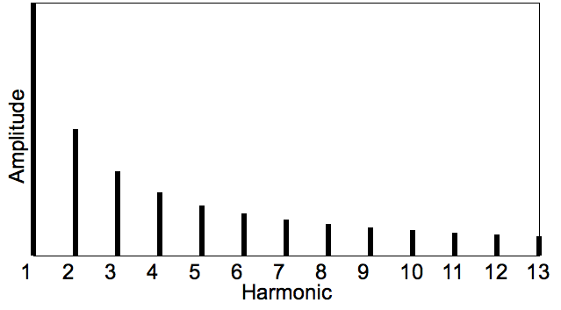
Fig 1. Overtone spectrum of an ideal harmonic instrument

Any deviation from this ideal overtone series is known as inharmonicity. Stringed instruments that are plucked (guitar, piano), rather than rubbed (violin, cello) have larger inharmonicity. The lower the elasticity of a string (in strings that are thicker, shorter, stiffer and/or have lower tension) the stronger its inharmonicity characteristics. Elastic properties (the lack of it) make percussion instruments inharmonic. Take the example below which shows the overtones of a bell with a fundamental frequency of 1650 Hz.

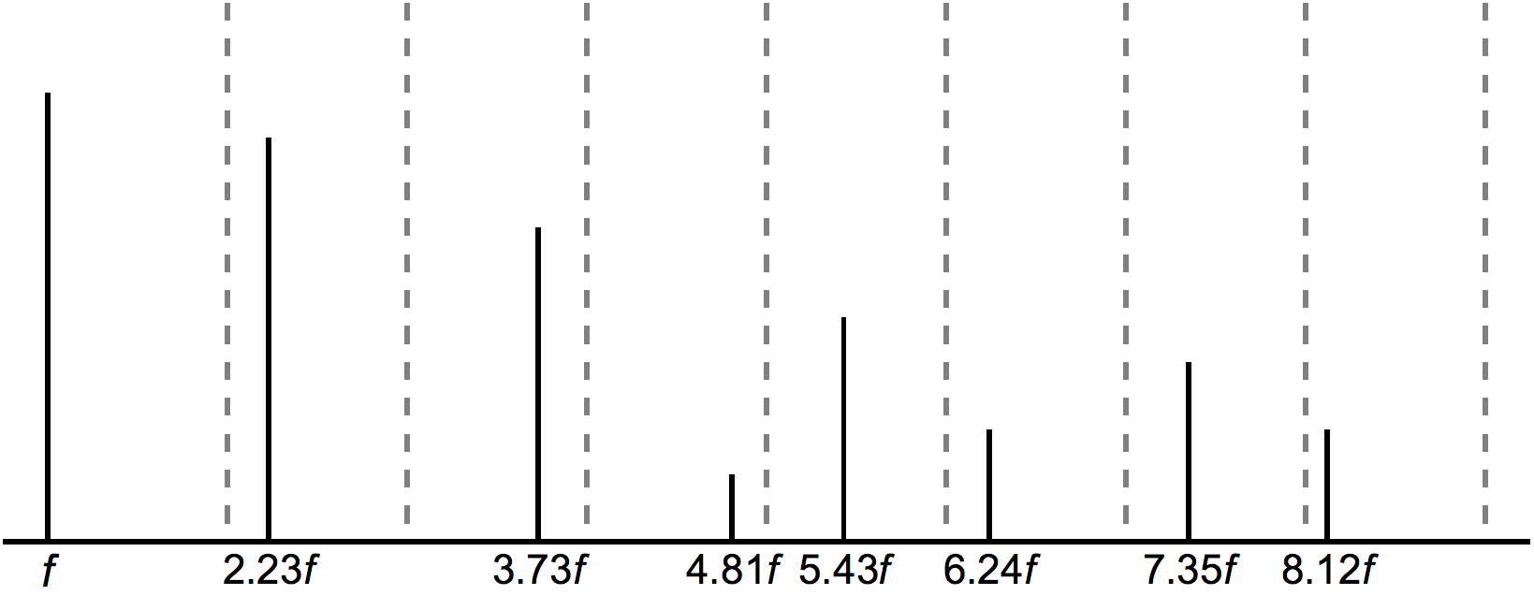
Fig 2. Overtone Spectrum of a Bell (dashed lines are integer overtones locations)

Inharmonicity is not necessarily synonymous with unpleasant sounds. The ability for a human ear to distinguish between a guitar and a violin is due to their differences, which includes their inharmonicity characteristics. Inharmonicity can make it more difficult to tune an instrument by ear as the tuner needs to compare notes with well defined relationships (e.g. a note that is one octave higher will have double the frequency if perfectly harmonic). The amount of difficulty in tuning by ear variers from instrument to instrument and even between ranges of notes for a single instrument – the more inharmonic the note that is played, the harder it is to obtain the right pitch.

- State whether the following changes to a string would increase or decrease its fundamental frequency. (3 marks)

Change | Increase/Decrease
Increasing the length
Increasing the tension
Changing to a denser material

- Explain how increasing the tension of a string will change its fundamental frequency. Include relevant formulas. (3 marks)

- The thick horizontal line on the grids below represents a string of a perfectly harmonic instrument. Based on the information provided in Fig 1, sketch the fundamental wave and the second harmonic envelopes that would be present in this string when played. (3 marks)
Fundamental

Second Harmonic

- Calculate the difference, in Hz, between the first overtone of the bell in Fig 2 and its first integer overtone if it was perfectly harmonic. (3 marks)

Difference: ___________________ Hz

- Professional tuners adjust the strings of an instrument, so each string plays a note at the right pitch.

  - Argue which instrument would be harder to tune by ear, the violin or the guitar.
(3 marks)

  - Argue which instrument would be harder to tune by ear, a guitar (thinner strings) or a bass guitar (thicker strings). (3 marks)

- (17 Marks)

Terminal Velocity

Introductory Physics classes will often state the acceleration of objects falling near the Earth’s surface as 9.8 m s⁻². While this is true in the absence of any air resistance, ignoring air resistance can lead to gross errors between theory and practical results. Objects falling through a fluid, such as Earth’s atmosphere, eventually reach a terminal velocity – the point where no further acceleration occurs.

There are three stages of falling:

- Acceleration from rest
- Acceleration while moving
- Zero acceleration

When an object first starts to fall, from a resting position, there is no air resistance. The initial acceleration of the object will be 9.8 m s⁻².

The object will push particles in the air out of the way as it falls. The faster the object falls, the more air it pushes out of the way each second. This is what causes air resistance. At some velocity, the acceleration of the object will be noticeably less than 9.8 m s⁻² and will continue to drop as the object picks up speed.

When the object is falling fast enough, there is so much air to push out of the way that the air resistance is just as large as the gravitational force pulling the object down. This causes the acceleration of the object to drop to zero. The object then maintains this falling speed – terminal velocity has been reached.

- The forces acting on an object falling through the atmosphere determine its acceleration. Draw a free body diagram of the physical forces acting on an object at each of its three stages of falling. Label all forces and keep all free body diagrams to the same scale.
(5 marks)

Acceleration from rest
Zero acceleration
Acceleration while moving

- The velocity-time graph below shows a bowling ball falling through the atmosphere.
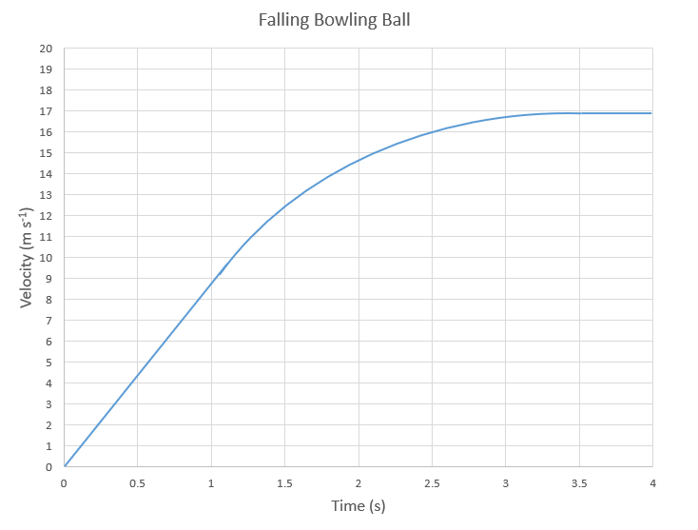

- Identify and clearly label the region of the graph that shows the first stage of falling as described in the text. (1 mark)

- Identify and clearly label the region of the graph that shows the third stage of falling as described in the text. (1 mark)

- Using the graph in part (b), estimate the distance covered by a bowling ball in the first 4.0 s through Earth’s atmosphere. (4 marks)

Distance: ___________________ m
- On the graph of the bowling ball falling through the atmosphere below, sketch a theoretical velocity-time graph of a golf ball dropped at the same time as the bowling ball, ignoring air resistance. (2 marks)

- Explain why Newton’s 3rd law of motion is relevant when explaining the cause of air resistance. (4 marks)

End of Questions
Additional working space

Additional working space

Additional working space

Additional working space

Additional working space

End of Examination
\Acknowledgements

Question 20
Fig 1. Overtone spectrum of an ideal harmonic instrument
Hyacinth, CC BY-SA 3.0 <https://creativecommons.org/licenses/by-sa/3.0>, via Wikimedia Commons

Fig 2. Overtone Spectrum of a Bell
Hyacinth, CC BY-SA 4.0 <https://creativecommons.org/licenses/by-sa/4.0>, via Wikimedia Commons

